Lab 09

Title
Introduction to Functions in C++
Objective
To understand the concept of functions in C++ and learn how to define and call functions in a program.

Apparatus / Software Required
- Computer
- C++ Compiler (Code::Blocks / Dev C++ / Visual Studio / Online Compiler)

Theory
A function in C++ is a block of code that performs a specific task.
Functions help to:
- Organize code properly
- Avoid repetition
- Make programs easier to read and maintain

Types of Functions:
- Built-in functions (e.g., cout, cin)
- User-defined functions (created by the programmer)

Basic Structure of a Function:
return_type function_name(parameters)
{
// body of function}

Example Program

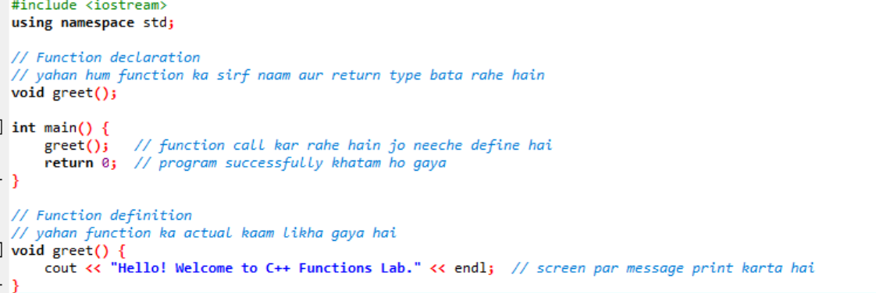

Working
- The function greet() is declared before main().
- Inside main(), the function is called.
- The function prints a greeting message.

Output
Hello! Welcome to C++ Functions Lab.

Conclusion
In this lab, we learned how to create and use functions in C++. Functions make programs easier to manage and improve code reusability.

Lab 09 Tasks
1:Function Introduction and Declaration
• Declare a function called”greet”that takes no parameters and returns nothing.
• Inside the function, display a greeting message of your choice.
• Call the function from the main program to execute the greeting.
Code:
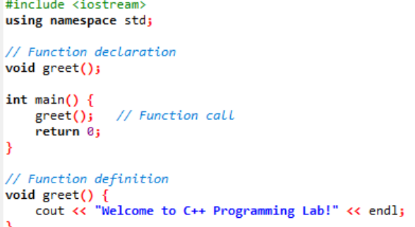

2: Basic Function Declaration and Call
- Declare a function called ”sayHello” that takes no parameters and return nothing.
- Inside the function, display the message ”Hello, World!”.
- Call the function from the main program to execute the greeting.
Code:
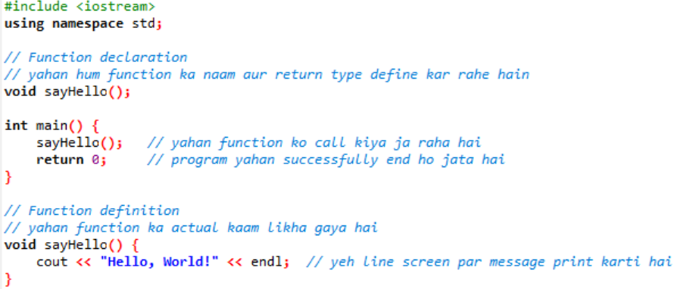
3: Write a C++ program that:
- Takes 10 integer values as input from the user and stores them in a 1D array.
- Creates a function named calculateSum that:
- Accepts the array and its size as parameters Returns the sum of all elements In the main() function:
- Call the function Calculate and display the average of the array elements Constraints
- Use only one-dimensional array Use function for sum calculation
Code:
